Lesson Plan
“Operations of Agricultural Machinery: Science of Stability”

Instructor:
Course:
Unit:
Lesson Title:
Estimated Time:
Objective(s) of Lesson: What you want your students to KNOW and/or be able to DO
Objectives of Seminar:
- Properly inspect tractors for safety equipment
- Hitch and back equipment safely using recommended industry standard hand signals
- Recognize and avoid hazardous situations involving hitching and backing of tractors
- Safely perform front end loader operations using recommended industry standard hand signals.
- Explain center of gravity, turning moments, and equilibrium
- Develop an instructional obstacle course for teaching tractor operations
- Research safe technology to assist hitching and backing of tractors
- Identify safety recommendations in matching tractor size and tasks with the age and ability of the tractor operator.
- Perform a SAE risk assessment for tractor operations

Materials, Supplies, Equipment, References, and Other Resources:
Situation: (WHO are you teaching)
Agricultural Education Teachers interested in updating SAE safety and agricultural mechanics safety. Motivation includes incorporating academic content (physics and math) with hands-on activities.

Interest Approach (Motivation):
Interest Approach

Farm tractors accounted for the deaths of 1,533 people between 2003 and 2011 and were of fatal occupational injuries in agriculture, forestry, and fishing. Today, tractor incidents remain the leading source of death and injury on farms. In 2011, only 59 percent of tractors had rollover protective structures (ROPs).

1/3 of farm fatalities are tractor related
50% of tractor related fatalities are from tractor rollovers both side and rear.
Before we begin today, we’d like you to think about some answers to the following question.

How do we decide what to focus your supervision on?

Next, we have a short video for you.

Show video and facilitate discussion questions for a total of five minutes.
http://natgeotv.com.au/videos/brain-games/jason-silva-on-focus-6DB34C36.aspx

Interest Approach Questions for Discussion:
How stretched are you with processing all your whole program’s needs?
What about your students SAE needs?
How do we decide what is useful information?
When does a person run on autopilot?
Can you do this your eyes close?
What do we really see?

Communicate Objectives, Define Problem or Decision to be Made, or Identify Questions to Investigate:
Today we will more about opportunities for injury prevention and control by proper planning of SAE supervision specific to tractor operations.

For our purposes, injuries are a result of an uncontrolled interaction between a host, an agent, and the environment. This seminar will be focused on safe tractor operations and assessing risks. The goal will be to accomplish as synergy in safety utilizing academic content standards and hands-on activities.

Instructor Directions / Materials  HOW you will teach | Content Outline, Instructional Procedures, and/or Key Questions  WHAT you will teach
- Pre-test  - Tractor and Implement Operations Opening slides  - NSTOMP Task Sheet 1 – Sections 1.2; 1.2.1; 1.2.2 | Large Group with all teachers:  - Collect Pre-test data  - Introduction with an overview of the agenda and purpose of research. Outline the rotations then ask for questions on logistics and rotation. Then have the teachers take pretest.  - Each rotation will be two hours.  - Show the website http://www.youthrules.gov/know-the-limits/agriculture/index.htm discuss what is allowable.  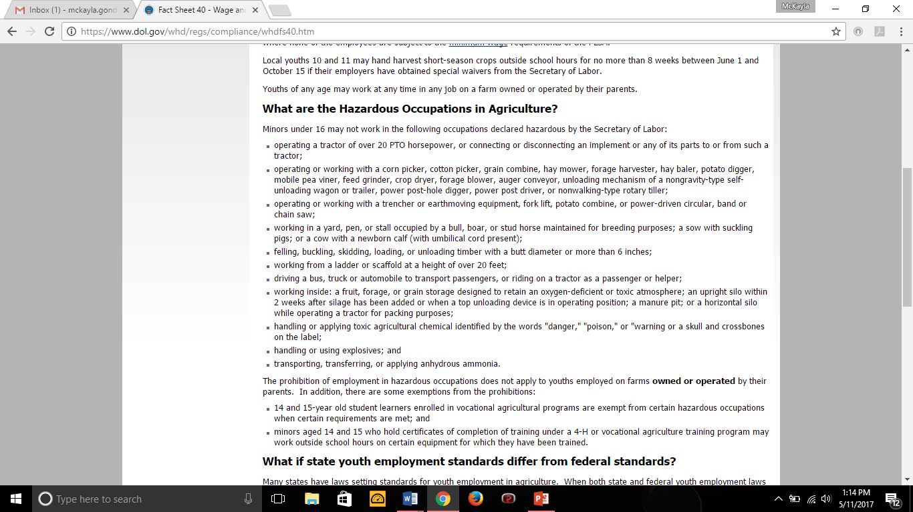  Review Tractor Controls and Pre-operation inspections
- Tractor and Implement operations Obstacle Course slides  - Walk-Around Inspection sheet using SAE Risk Assessment and NSTMOP Hands-on obstacle course development  - NSTMOP Course Evaluation  - Safe Tractor controls Tabletop Classroom activity | *Small Group Break Out Session*  Rotation 1  Accomplishing:  - Properly inspect tractors for safety equipment  - Develop an instructional obstacle course for teaching tractor operations  - Perform a SAE risk assessment for tractor operations  https://www.youtube.com/playlist?list=PL66E3F5E433A5D988 Video on hazards of tractors and Machinery.  https://youtu.be/VX6725s95p4 Older video tractor basic operations  https://youtu.be/hZWmgC8t6Zc Newer OSHA tractor operations training  Follow-up the videos up with hands-on activity.  Hands-on Activity  Demonstrate how to set up obstacle course.  Have teachers conduct  • Pre-operation inspection  - Review Tractor controls  • Three courses (participants rotate through)  ○ 1 smaller tractor (lawn tractor) with garden/utility cart  ○ 1 tractor with wider implement  ○ 1 skid steer  • Closing  ○ Discussion of integration into program  Option 1: Have tractors and equipment on site for walk-around and inspect using SAE sheets, SaferFarm, or checklist from NSTMOP. Use the Hands-on obstacle course development sheet to have teachers measure and layout an obstacle course using traffic cones. Let teachers complete the obstacle courses. Ask teachers to consider alternative course set ups.  Option 2: If no trailers or implements are available, Instructors can use tractors to measure wheel base dimensions and set the course without implements using traffic cones. If only tractors are available, the course layout form will need to be modified to match equipment.  Option 3: If only one tractor can be acquired or borrowed, instructors can rotate through measuring the wheel base and setting an obstacle course You may decide to assign different course layouts for each group. This will allow smaller groups to work independently from each other. This allows for more participation.  In this rotation, you will be inspecting tractors for safety equipment and developing an obstacle course to evaluate student driving performance.  The top items to inspect on every tractor are….  Resources:  2017 Organizing and Conducting a Safe Tractor Operations Workshop
- Tractor and implement operations backing and hitching slides  - NSTMOP Task Sheet Section 4  - 2017 Penn State Guide to conducting a safe tractor operations workshop  - STEM Backing tractors tabletop Classroom activity | *Small Group Break Out Session*  Rotation Two  Accomplishing Objective:  Hand on Activity  Hitching and Backing Using Hand Signals  - Hitch and back equipment safely using recommended industry standard hand signals  - Safely perform front end loader operations using recommended industry standard hand signals.  Discuss the ASABE hand signals  • Multiple rotations  ○ Hitching - tractor  ○ Backing - lawn trailer  ○ Front implement operation  § Skid steer  § Pallet stacking contest  Show videos of implement connections  All types of connections: https://youtu.be/rt4_vYcGMWM  Assign teachers into groups of three to four.  At this station teachers will complete the following task as a group:  - Teacher will back the tractor/vehicle to connect to implement using a helper to guide. The helper will connect the implement to the tractor. Be sure tractor operator locks the parking brake and sets the transmission in neutral.  - Tractor operator will then then pull forward and then back up in to the designated zone. The helper will then unhitch the implement or trailer. Helpers must remain in visual contact and use hand signals.  - Tractor operator will pull forward and then shut off the tractor. Be sure to set the parking brake and set the transmission in neutral.  Rotate teachers so that each one can practice.  Types of hitching for hands-on:  - Drawbar pin  - Trailer ball  - Three-point hitch.  Could include connecting PTO shaft and hydraulic hoses if time allows.  Front end loader:  - Skid steer with forks to have teachers to move and stack pallets. This one will get teachers to recognize blind spots of equipment.  - Review visibility of operators while hitching and backing equipment  - Ask how should we communicate with the engine noise or a person inside a cab?  • Wrap up  - What were the visibility differences between the three?  - How do we decrease hazards associated with backing up?  - Design facility to eliminate the need for backing equipment
- STEM Lesson Hitching Mechanics Worksheet  - Cushion it activity  - PPE Demonstration Lab Activity | *Small Group Break Out Session*  Rotation Three  Accomplishing Objectives  - Recognize and avoid hazardous situations involving hitching and backing of tractors.  - Explain center of gravity, turning moments, and equilibrium  Discuss impact forces and moments  Discuss collisions and falls  https://www.physicsclassroom.com/Class/momentum/u4l1b.cfm#rebound  https://www.physicsclassroom.com/class/momentum/U4l1c.cfm#rebound  Complete hands-on activity  Hands-On Activity  - PPE Demonstration (impact of forces)  - STEM Hitching Mechanics lesson (moments)  Students can then build demonstration units as part of hands-on skill development and demonstrate to the class their safety instruction function. Teachers and students could then use the kits to provide community outreach.
- Tractor and Implement Operations closing slides  - NSTOMP Task Sheet Section 2 | Large Group  Accomplishing Objective 7:  - Research safe technology to assist hitching and backing of tractors  - Identify safety recommendations in matching tractor size and tasks with the age and ability of the tractor operator.  http://www.youthrules.gov/index.htm  End session with a review of youthrules.gov so that SAE multiple types can be addressed.
Application: | Throughout the unit
Closure/Summary: | Closing summary and assessment of students
Evaluation: | Post-test

